7
Harvesting Intelligence: AI and ML Revolutionizing Agriculture

Arya Kumari, Muhammad Najeeb Khan, and Amit Kumar Sinha
Shri Mata Vaishno Devi University, Katra, India

INTRODUCTION
Agriculture has been the backbone of human civilization for millennia, and with the advent of technology, it is undergoing a remarkable transfor- mation. Machine learning (ML), with its ability to process vast amounts of data and extract meaningful insights, is playing a pivotal role in revo- lutionizing the agricultural industry. In this chapter, we will explore the diverse applications of ML in agriculture and how it is enhancing produc- tivity, sustainability, and overall efficiency.

PRECISION FARMING AND CROP MANAGEMENT

Crop Yield Prediction
ML plays a crucial role in crop yield prediction, as it can leverage histori- cal and real-time data to build predictive models that estimate future crop yields accurately. Here’s the pictorial representation (Figure 7.1) of how ML can be used in crop yield prediction:
Now let’s see a brief explanation of each step, as shown in Figure 7.1
      - Data Collection and Preprocessing:
        - Clean and preprocess the data to handle missing values and outli- ers, and ensure data consistency.
126 DOI: 10.1201/9781003485179-7

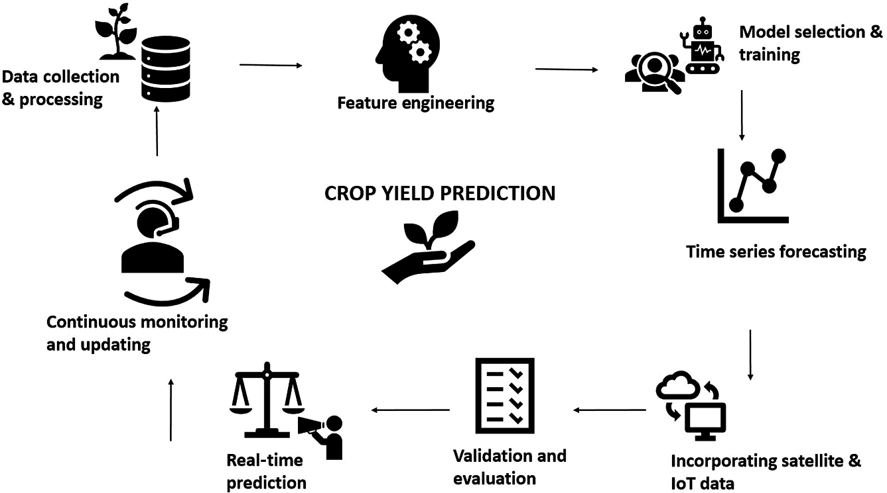

FIGURE 7.1
Crop yield prediction with the help of ML.

      - Feature Engineering:
        - Select and engineer relevant features from the collected data that can influence crop yields, such as temperature, precipitation, soil moisture, and fertilization methods.
      - Model Selection:
        - By choosing an appropriate ML algorithm based on the nature of the problem (some commonly used algorithms are linear regres- sion, decision trees, random forests, support vector machines (SVM), neutral network, time series forecasting, and many more) and the size of the dataset, we can predict crop yield.
      - Model Training:
        - By splitting the dataset into training and validation sets, we eval- uate the model’s performance and train the chosen ML model on the training set, adjusting the models parameters to minimize prediction errors.
      - Time Series Forecasting:
        - For crop yield prediction involving time series data, select models specifically designed for time-dependent patterns, such as autore- gressive integrated moving average (ARIMA), seasonal decom- position of time series (STL), or long short-term memory (LSTM) networks.
      - Incorporating Satellite and IoT Data:

        - Integrate satellite imagery data and IoT sensor data, such as soil moisture sensors and weather stations, to capture real-time infor- mation about crop health and environmental conditions.
        - Satellite data can provide insights into vegetation indices and crop growth, while IoT data can offer detailed information on local environmental variables.
      - Validation and Model Evaluation:
        - Validate the model’s performance on the validation set and use appropriate evaluation metrics, such as mean squared error (MSE) or root mean squared error (RMSE); after that, fine-tune the model if needed and perform cross-validation to ensure its generalizability.
      - Real-Time Predictions:
        - Once the model is trained and validated, it can be used for real- time crop yield predictions (by using algorithms like supervised learning algorithms) based on current weather conditions and other input variables.
      - Continuous Monitoring and Updating:
        - Continuously monitor the performance of the crop yield predic- tion model and update it regularly with new data.

Disease Detection and Pest Management
Utilizing computer vision and image analysis to detect diseases in crops has become a game-changer in modern agriculture. By harnessing the power of ML and image processing techniques, farmers can quickly and accurately identify diseases and pests that affect their crops, enabling them to take timely and targeted actions for disease management. Here’s a brief explanation of how computer vision and image analysis are used for disease detection in crops:

      - Image Acquisition and Preprocessing:
        - High-resolution images of crops are captured using various sources, such as drones, satellites, or mounted cameras.
        - Preprocessing techniques are applied to enhance image quality, remove noise, and correct any image distortions or artifacts.
      - Segmentation of Plant Regions:
        - Computer vision algorithms are employed to segment the plant regions of interest from the background in the images.

        - This step ensures that only the relevant parts of the image are analyzed, focusing on the leaves or affected areas.
      - Feature Extraction:
        - Relevant features, such as color, texture, shape, and size of the plant regions, are extracted from the segmented images.
        - These features serve as essential inputs for disease classification models.
      - Disease Classification:
        - ML algorithms, such as SVM, convolutional neural networks (CNN), or decision trees, are trained using labeled datasets of healthy and diseased crops.
        - The models learn to differentiate between healthy and infected crops based on the extracted features.
      - Disease Identification and Diagnosis:
        - Once the model is trained, it is deployed to predict disease pres- ence in new, unseen images of crops.
        - The model classifies the crop as healthy or identifies the specific disease or pest affecting it.
      - Early Detection and Monitoring:
        - Continuous monitoring of crops using computer vision enables early detection of diseases before they spread extensively.

SOIL HEALTH AND NUTRIENT MANAGEMENT

Soil Fertility Analysis
Analyzing soil fertility using ML involves a series of steps to process and analyze soil data, build predictive models, and interpret the results. Here’s a step-by-step process for soil fertility analysis using ML:
      - Data Collection:
        - Gathering soil samples from various locations in the field, ensur- ing they are representative of the entire area, which gives relevant information about each sample, such as soil type, pH, organic matter content, nutrient levels (nitrogen, phosphorus, potassium, etc.), and other soil properties.
      - Data Preprocessing:

        - Cleaning the data by handling missing values and removing any outliers.
        - Normalizing the numeric features to ensure that they have the same impact on the model.
      - Feature Selection:
        - Using techniques such as correlation analysis or feature impor- tance from ML models to select relevant features.
      - Building the ML Model:
        - Choosing a suitable ML algorithm for soil fertility prediction. Common algorithms include linear regression, decision trees, random forests, SVM, and gradient boosting machines (GBM). We can split the data into training and testing sets to evaluate the model’s performance.
      - Model Training:
        - Adjust hyperparameters to optimize the model’s performance. We can use techniques like grid search or random search for hyper- parameter tuning.
      - Model Evaluation:
        - Evaluate the model’s performance on the testing set using appro- priate evaluation metrics such as Mean Absolute Error (MAE), RMSE, or R-squared.
        - Compare the results with domain-specific thresholds to deter- mine the model’s accuracy.
      - Interpretation of Results:
        - Analyze the model’s coefficients or feature importance to under- stand which soil properties have the most significant influence on soil fertility. And interpret the predictions to identify areas with low or high soil fertility.
      - Validation and Refinement:
        - Validate the model’s performance using new soil samples col- lected independently from the training and testing sets.
      - Deploying the Model:
        - Integrate the model into an application or system that allows users to input soil data and receive fertility predictions.
      - Continuous Monitoring and Updates:
        - Continuously monitor the model’s performance and update it regularly with new data to improve accuracy and adapt to chang- ing soil conditions.

Irrigation Optimization
The implementation of sensor networks to monitor soil moisture levels and weather conditions is represented in Figure 7.2.
Employing ML algorithms to create intelligent irrigation systems, as shown in Figure 7.3.
Reducing water waste and ensuring adequate hydration for crops, as mentioned in Figure 7.4.
The role of reinforcement learning in dynamically adjusting irrigation schedules is shown in Figure 7.5.

LIVESTOCK MANAGEMENT

Automated Monitoring of Livestock
Automated monitoring of livestock is a technology-driven approach that involves using various sensors, devices, and data analytics to continuously monitor and track the health, behavior, and well-being of livestock in agri- cultural settings. This advanced monitoring system can provide real-time information to farmers, allowing them to identify and address potential issues promptly. Here’s how automated monitoring of livestock works (Figure 7.6):

      - Wearable Devices and Sensors:
        - Livestock wear devices such as GPS-enabled collars, ear tags, or leg bands containing sensors.
        - These sensors can monitor vital signs like body temperature, heart rate, respiration rate, and activity levels of the animals.
      - Tracking and Localization:
        - GPS-enabled devices track the location and movements of live- stock in the field or grazing areas.
        - This helps farmers keep track of their animals’ whereabouts, pre- vent straying, and ensure efficient grazing management.
      - Health and Behavior Monitoring:
        - Sensors continuously monitor the health and behavior of the animals.
        - Anomalous behavior, such as decreased activity or changes in feeding patterns, can indicate health issues or stress.

132 • Data-Driven Farming

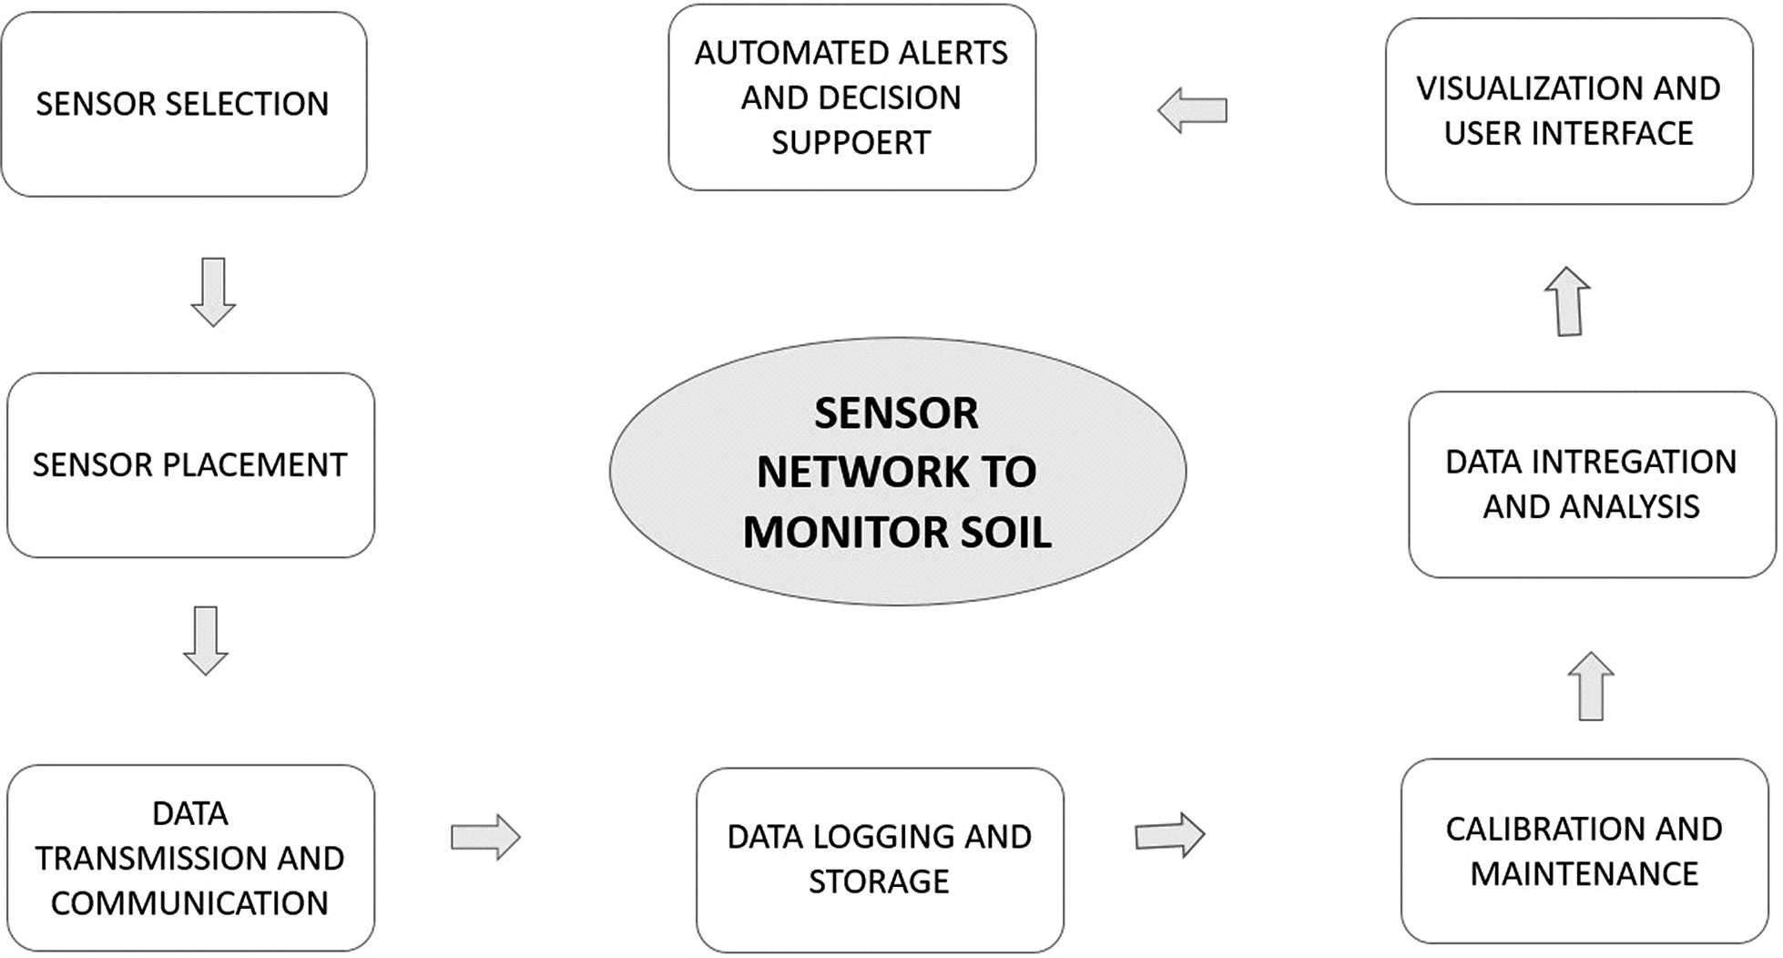

FIGURE 7.2
Implementation of sensor networks.

Harvesting Intelligence • 133

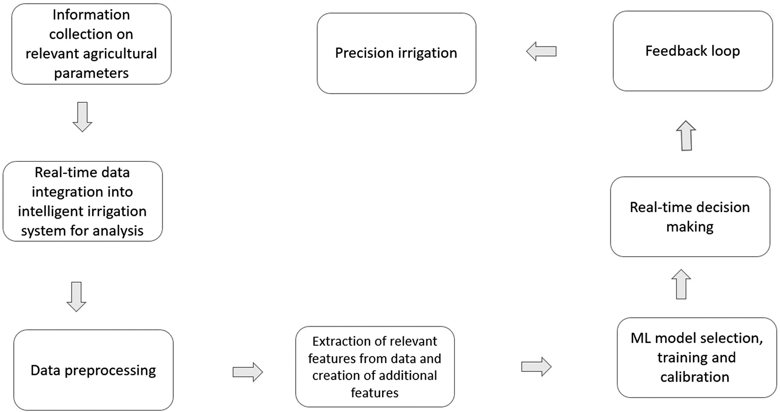

FIGURE 7.3
Intelligent irrigation systems.

134 • Data-Driven Farming
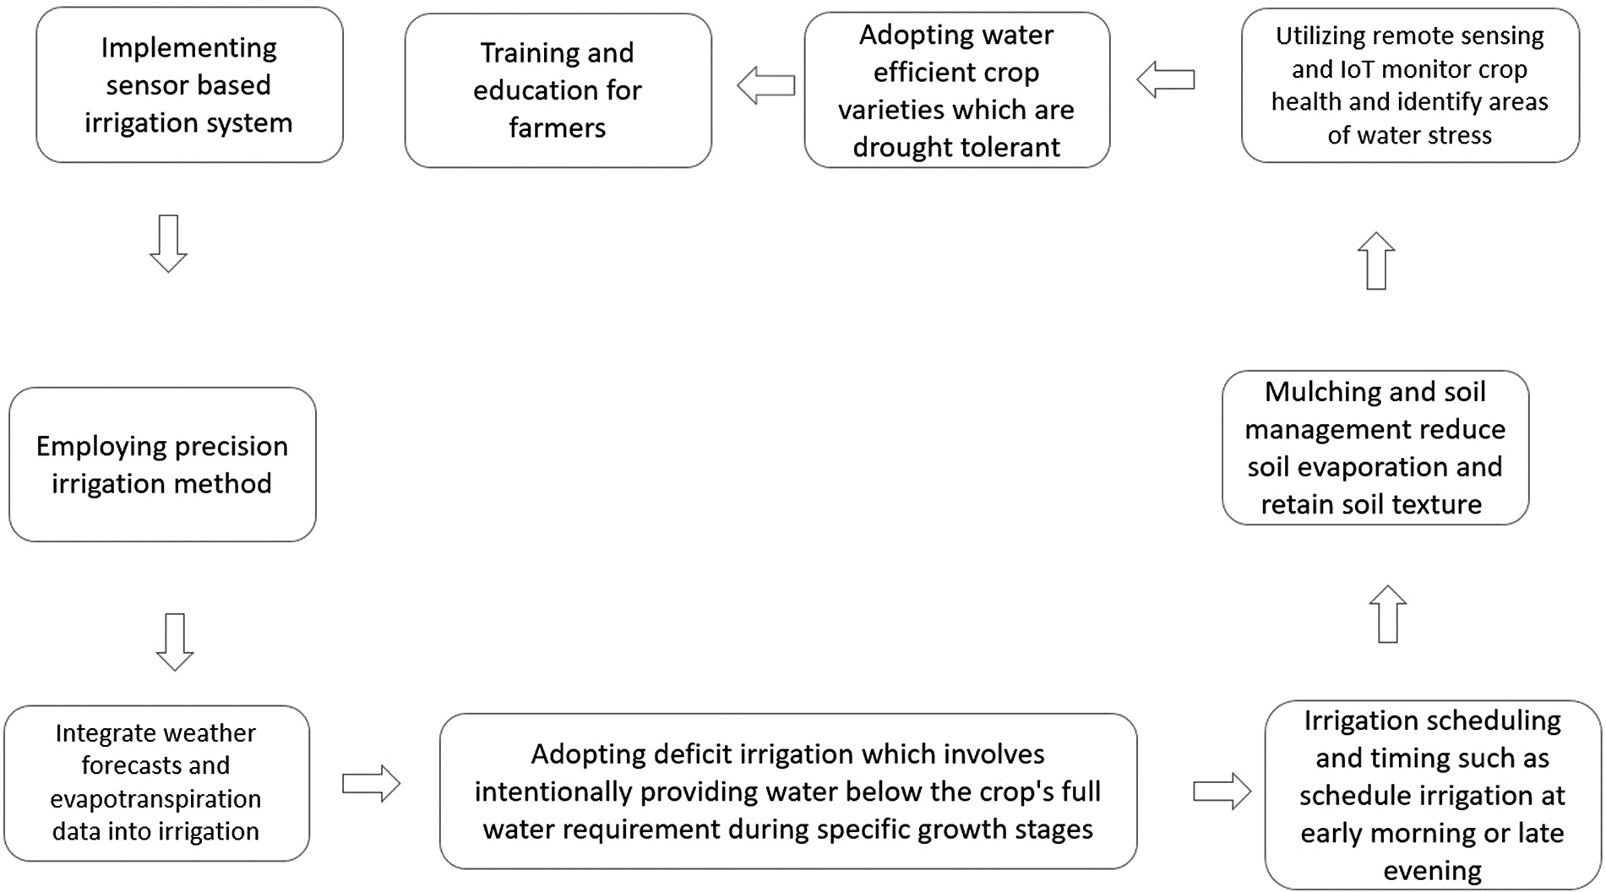

FIGURE 7.4
Adequate hydration for crops.

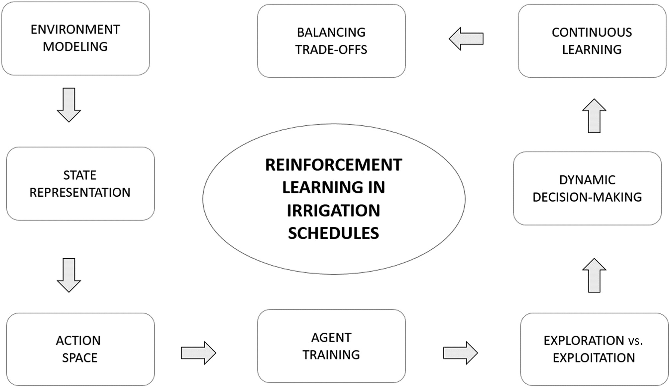
Harvesting Intelligence • 135

FIGURE 7.5
Dynamical adjustment of irrigation schedules.

136 • Data-Driven Farming
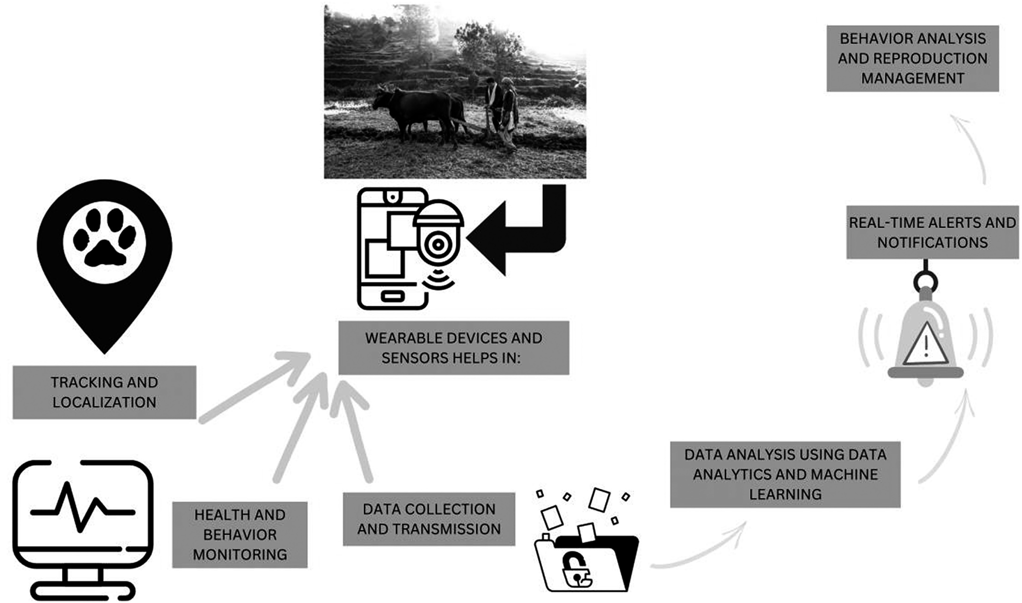

FIGURE 7.6
Automated monitoring using sensors, devices, and data analytics.

      - Data Collection and Transmission:
        - The sensor devices collect data from the livestock, and the infor- mation is transmitted wirelessly to a central data collection system.
        - Data may be sent to cloud-based platforms or local servers for storage and analysis.
      - Data Analytics and ML:
        - Data from multiple livestock are analyzed using data analytics and ML algorithms.
        - These algorithms can identify patterns and trends that may indi- cate specific health conditions or stress factors.
      - Real-Time Alerts and Notifications:
        - When abnormal data or predefined thresholds are detected, the system generates real-time alerts or notifications.
        - Farmers receive these alerts on their smartphones or computers, allowing them to take immediate action.
      - Remote Monitoring and Management:
        - Farmers can access the monitoring system remotely to check the health status and location of their livestock.
        - This feature is particularly useful for large-scale livestock opera- tions or when animals are grazing in distant areas.
      - Behavior Analysis and Reproduction Management:
        - Automated monitoring can help in detecting estrus behavior in female animals, assisting in proper timing for breeding.
        - Behavior analysis may also identify signs of distress or disease early on, enabling timely intervention.

FEED OPTIMIZATION
Feed optimization using ML is an innovative approach in agriculture to efficiently manage animal nutrition and reduce feed costs while maxi- mizing animal health and productivity. ML algorithms can analyze large amounts of data to create personalized and optimized feeding plans for livestock. Here’s how feed optimization using ML works:

- Data Collection:
  - Gather data on animal characteristics, such as species, breed, age, weight, and physiological status (e.g., lactating, gestating).

  - Collect nutritional information about various feed ingredients, including nutrient composition and digestibility.
- Nutrient Requirements:
  - Define the nutritional requirements for different classes of ani- mals, considering their growth stages, reproductive status, and production goals.
  - Nutrient requirements are typically based on scientific guidelines and established feeding standards.
- Formulating the Problem:
  - Convert the feed optimization problem into an ML problem by formulating it as an optimization task.
  - Define the objective function, which could be maximizing ani- mal productivity (e.g., milk yield, weight gain) while minimizing feed costs.
- Data Preprocessing:
  - Clean and preprocess the data, handling missing values and out- liers to ensure data quality.
- Feature Engineering:
  - Extract relevant features from the data, such as animal character- istics and nutrient compositions of feed ingredients.
  - Create composite features or ratios that represent the nutritional balance required for specific animal classes.
- Model Selection:
  - Choosing appropriate ML algorithms based on specific feed opti- mization problems like regression, linear programming, and genetic algorithms, which are commonly used for feed optimiza- tion tasks.
- Model Training:
  - Train the ML model on historical feeding data, which includes feed formulations and corresponding animal performance data, which learns to identify optimal feed combinations that meet the animals’ nutritional requirements.
- Model Validation and Evaluation:
  - Validating the ML model’s performance on a separate dataset or through cross-validation we can evaluate the models ability to generate cost-effective feed formulations while meeting animal nutritional needs.
- Real-Time Feed Formulation:

  - Deploying the trained ML model in an automated feed formula- tion system, which is based on real-time data about animals and available feed ingredients and generates personalized and opti- mized feed plans.
- Continuous Learning and Updates:
  - Continuously monitoring the animal performance and feed costs to gather new data, which helps in regular updating of the ML model to improve its accuracy and adapt to changing feed ingre- dient availability or nutritional requirements.

CONCLUSION
ML is transforming agriculture by providing data-driven insights and decision-making capabilities. Precision farming, crop management, soil health analysis, and livestock management are just a few areas where ML applications are making a significant impact. As technology continues to advance, the agriculture industry stands to benefit even more from these innovations, leading to sustainable farming practices, increased yields, and improved food security. However, challenges such as data privacy, adoption barriers, and the digital divide must be addressed to ensure the widespread adoption of these transformative technologies. By combining domain expertise with ML capabilities, agriculture is poised to embrace a new era of productivity and sustainability.

BIBLIOGRAPHY
Ahmad, Latief, and Firasath Nabi. Agriculture 5.0: Artificial Intelligence, IoT and Machine Learning. CRC Press, 2021.
Alreshidi, E. Smart sustainable agriculture (SSA) solution underpinned by internet of things (IoT) and artificial intelligence (AI). (2019). arXiv preprint arXiv:1906.03106. Anitha Mary, X., Popov, V., Raimond, K., Johnson, I., and Vijay, S. J. Scope and recent trends of artificial intelligence in Indian agriculture. The digital agricultural revolu-
tion: Innovations and challenges in agriculture through technology disruptions. 1–24, Wiley, 2022.
Dakir, A., F. Barramou, and O. B. Alami. Opportunities for artificial intelligence in preci- sion agriculture using satellite remote sensing. Geospatial Intelligence: Applications and Future Trends. 107–117, 2022. https://doi.org/10.1007/978-3-030-80458-9_8
Javaid, M.A. Haleem, I. H. Khan, and R. Suman. Understanding the potential applications of artificial intelligence in agriculture sector. Advanced Agrochem 2.1. (2023): 15–30.

Jung, J., M. Maeda, A. Chang, M. Bhandari, A. Ashapure, and J. Landivar-Bowles. The potential of remote sensing and artificial intelligence as tools to improve the resil- ience of agriculture production systems. Current Opinion in Biotechnology 70 (2021): 15–22.
Khan, Yusuf Mustafa, and Sandeep Kumar. Applications of artificial intelligence in agricul- ture. International Research Journal of Modernization in Engineering Technology and Science 3 (2021): 1398–1402.
Khandelwal, Paras M., and Himanshu Chavhan. Artificial intelligence in agriculture: An emerging era of research. ResearchGate Publication, 2019.
Linaza, M. T., J Posada, J. Bund, P. Eisert, M. Quartulli, J. Döllner, A. Pagani, I. G. Olaizola,
A. Barriguinha, T. Moysiadis, and L. Lucat. Data-driven artificial intelligence applica- tions for sustainable precision agriculture. Agronomy 11 (2021): 1227.
Megeto, G. A. S., A. G. D. Silva,R. F. Bulgarelli, C. F. Bublitz, A. C. Valente, and D. A. G.
D. Costa. Artificial intelligence applications in the agriculture 4.0. Revista Ciência Agronômica 51 (2021): e20207701.
Mekonnen, Y., S. Namuduri, L. Burton, A. Sarwat, and S. Bhansali. Machine learning techniques in wireless sensor network based precision agriculture. Journal of the Electrochemical Society 167.3 (2019): 037522.
Misra, N. N., Yash Dixit, Ahmad Al-Mallahi, Manreet Singh Bhullar, Rohit Upadhyay, and Alex Martynenko. IoT, big data, and artificial intelligence in agriculture and food industry. IEEE Internet of Things Journal 9 (2020): 6305–6324.
Mitra, Alakananda, Sukrutha L. T. Vangipuram, Anand K. Bapatla, Venkata K. V. V. Bathalapalli, Saraju P. Mohanty, Elias Kougianos, and Chittaranjan Ray. “Everything you wanted to know about smart agriculture.” (2022). arXiv preprint arXiv:2201.04754.
Panpatte, D. G. Artificial intelligence in agriculture: An emerging era of research. Anand Agricultural University, 2018.
Sarkar, M. R.S. R. Masud, M. I. Hossen, and M. Goh. A comprehensive study on the emerg- ing effect of artificial intelligence in agriculture automation. In 2022 IEEE 18th International Colloquium on Signal Processing & Applications (CSPA), 2022 May 12,
pp. 419–424). IEEE.
Shadrin, D., A. Menshchikov, D. Ermilov, and A. Somov. Designing future precision agri- culture: Detection of seeds germination using artificial intelligence on a low-power embedded system. IEEE Sensors Journal 19.23. (2019): 11573–11582.
Sharma, A., M. Georgi, M. Tregubenko, A. Tselykh, and A. Tselykh Enabling smart agri- culture by implementing artificial intelligence and embedded sensing. Computers & Industrial Engineering 165 (2022): 107936.
Singh, Garima, Anamika Singh, and Gurjit Kaur. Role of artificial intelligence and the internet of things in agriculture. In Artificial Intelligence to Solve Pervasive Internet of Things Issues, pp. 317–330. Academic Press, 2021a.
Singh, P., and A. Kaur. A systematic review of artificial intelligence in agriculture. Deep Learning for Sustainable Agriculture. 57–80, 2022. https://doi.org/10.1016/ B978-0-323-85214-2.00011-2
Singh, Rajesh, and Anita Gehlot, Mahesh Kumar Prajapat, and Bhupendra Singh. Artificial Intelligence in Agriculture. CRC Press, 2021b.
Singh, Ritesh Kumar, Rafael Berkvens, and Maarten Weyn. AgriFusion: An architecture for IoT and emerging technologies based on a precision agriculture survey. IEEE Access 9 (2021c): 136253–136283.
Siregar, R. R. A., K. B. Seminar, S. Wahjuni, and E. Santosa. Vertical farming perspectives in support of precision agriculture using artificial intelligence: A review. Computers
11.9. (2022): 135.

Sishodia, R. P. R. L. Ray, and S. K. Singh. Applications of remote sensing in precision agri- culture: A review. Remote Sensing 12 (2020):3136.
Skvortsov, E. A. Prospects of applying artificial intelligence technologies in the regional agriculture. Ekonomika Regiona= Economy of Regions 2 (2020): 563.
Sood, Amit, Rajendra Kumar Sharma, and Amit Kumar Bhardwaj. Artificial intelligence research in agriculture: A review. Online Information Review 46.6 (2022): 1054–1075. Subeesh, A., and C. R. Mehta. Automation and digitization of agriculture using artificial intel-
ligence and internet of things. Artificial Intelligence in Agriculture 5 (2021): 278–291. Tzachor, Asaf, Medha Devare, Brian King, Shahar Avin, and Seán Ó hÉigeartaigh.
Responsible artificial intelligence in agriculture requires systemic understanding of risks and externalities. Nature Machine Intelligence 4.2 (2022): 104–109.
Yousaf, A., V. Kayvanfar, A. Mazzoni, and A. Elomri. Artificial intelligence-based decision support systems in smart agriculture: Bibliometric analysis for operational insights and future directions. Frontiers in Sustainable Food Systems. 6 (2023): 1053921.

